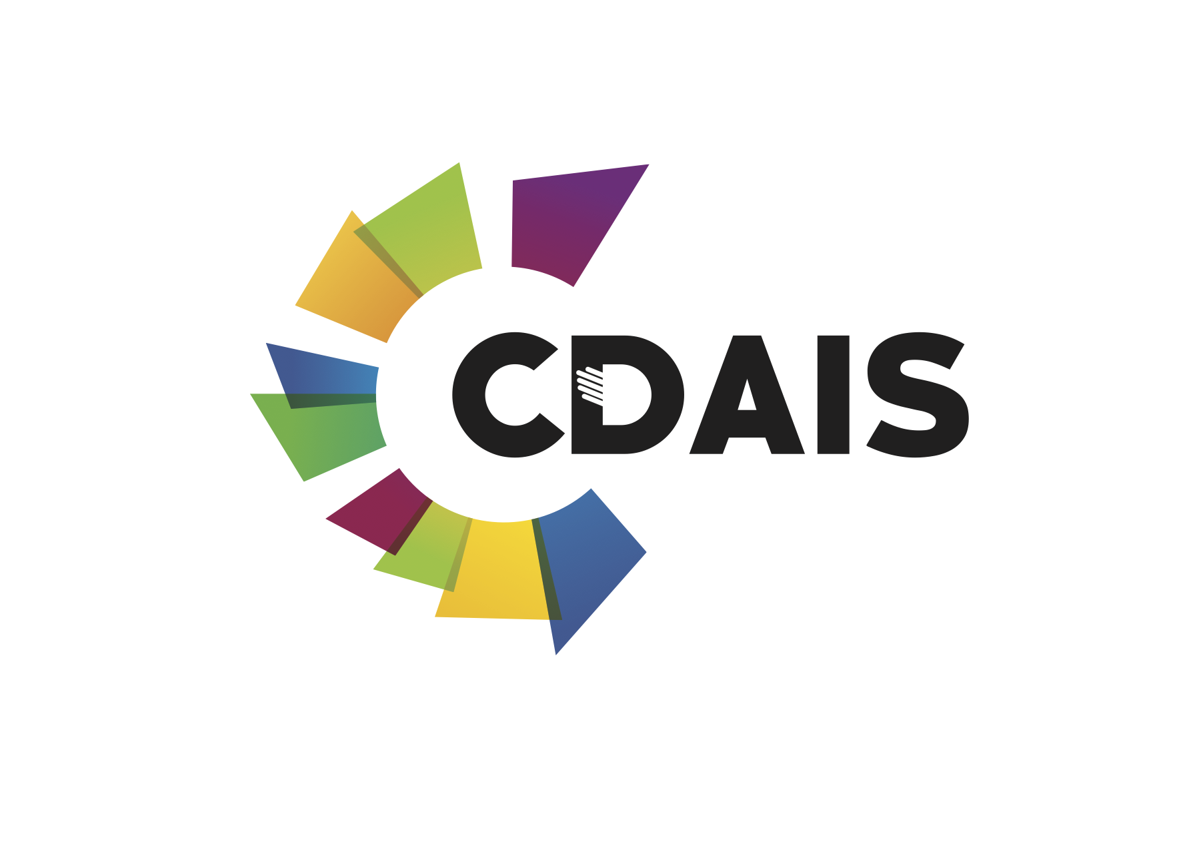

Montpellier, 9 April 2019

Press release
An international forum
STRENGTHENING FUNCTIONAL CAPACITIES TO INNOVATE.
SHARING THE NOW. SHAPING THE FUTURE.
Gembloux Agro-Bio Tech - Passage des déportés 2, B-5030 Gembloux, Belgium

Agrinatura, the Food and Agriculture Organization of the United Nations (FAO), along with the CDAIS (Capacity Building for Agricultural Innovation Systems) project team are announcing the first International Forum on Strengthening Functional Capacities to Innovate, to be held on 13-14 May 2019 in Gembloux, Belgium.

Interactive sessions will ensure knowledge sharing, learning and networking, among internationally renowned speakers and professionals from Africa, Asia, Europe, Latin America and USA. The aim is to engage actors; individuals and organisations to share knowledge and shape actions towards a greater commitment to invest in strengthening functional capacities to innovate in food and farming systems to meet the challenges of global food security and sustainable agricultural development. Quality content and dedicated spaces will allow participants to express, exchange and initiate innovative collaboration and develop project ideas for the future. The CDAIS Forum will take place before the Agrinatura General Assembly on 15-17 May 2019, also at Gembloux Agro-Bio Tech.

The world’s population is expected to grow from the current 7.7 billion to 8.5 billion by 2030, and 9.8 billion by 2050. But feeding these extra mouths, while essential, is not enough. There is also a need to consider the whole food systems, including the production, processing, distribution, consumption and disposal of food products and how these affect the economic, social and natural environment. Food systems rely on actors, their relationships and networks, and improving them requires people to work together within an enabling institutional framework across sectors towards sustainable solutions. There is thus a clear need for more comprehensive initiatives that can strengthen capacities to innovate at national and global scale.

“Over the past four years, the project developed, tested and validated an integrated approach to capacity development taking into account actors (individuals and organisations) and institutions (the enabling environment). We’ve worked with eight countries across the globe and which showed that our approach worked and is sustainable. We’ve engaged actors and institutions to sustain the changes achieved by the project.” Myra Wopereis, CDAIS Global Coordinator.

“CDAIS shows there is greater impact if global partnerships such as Agrinatura and FAO work directly with key national partners from Angola, Bangladesh, Burkina Faso, Ethiopia, Guatemala, Honduras, Laos and Rwanda.” Carolyn Glynn, Agrinatura President.

“The Forum will provide a space to reflect on the concepts used, how they were applied and implemented and how people and organisations worked together to achieve changes at various levels in the food system. It will not only focus on CDAIS results, but will also on global initiatives especially those led by the TAP partners who applied the CDAIS common framework in their own programmes.” Judith Francis, TAP Chair.

“The forum will also allow the policy makers from pilot countries and beyond to share their own experiences about the policy processes conducted which empowered the niche actors as well as raised awareness and understanding among policy makers about the importance of strengthening capacities to innovate.” Karin Nichterlein, TAP Secretariat/FAO.

Experts, Students and the Media are cordially invited to attend on May 13 and 14 . Places are limited. The programme and registration are available on Eventbrite.

CDAIS Global Coordinator
Myra Wopereis
About CDAIS
Launched in 2015, this Capacity Development for Agricultural Innovation Systems (CDAIS) initiative is funded by the European Union (EU) and implemented through a global partnership between Agrinatura representing a group of European research organisations, and FAO. The goal of CDAIS is to support agricultural innovation through the development of the functional capabilities of individuals and organisations in national agricultural innovation systems. Implemented in eight pilot countries in Africa (Angola, Burkina Faso, Ethiopia, Rwanda), Asia (Bangladesh, Laos) and Central America (Guatemala, Honduras), the CDAIS project developed methodologies and tools to that strengthened ‘functional capacities’, or what some call ‘soft skills’

Functional capacities defined
The ‘common framework’ supported by the project and facilitated by the Tropical Agricultural Platform (TAP), highlights specific functional capacities essential for agricultural innovation systems.
• Capacity to navigate complexity
• Capacity to collaborate
• Capacity to reflect and learn
• Capacity to engage in strategic and political processes
These four capacities result in the capacity ‘to adapt and respond in order to realize the potential of innovation’. The capacities are strengthened in three dimensions i.e. individual, organisational and the enabling environment. The approach shifts the focus from reactive problem solving to co-creating the future.
Source: https://tapipedia.org/framework

About the Tropical Agriculture Platform
The Tropical Agriculture Platform (TAP) was Initiated by the G20, and is generously supported by the European Union. Its main focus is the development of national capacities for agricultural innovation in the tropics, where most developing countries are located and the capacity gap is especially wide. By helping to bridge the capacity gap, TAP aims to pave the way for agricultural innovations that meet the demands of its principal users – small farmers, small and medium-sized agribusinesses and consumers. To achieve these goals, TAP has embraced the ‘agricultural innovation systems’ (AIS) perspective, acting as a multilateral dynamic facilitation mechanism that enables better coherence and greater impact of capacity development interventions in agricultural innovation.

About Agrinatura
Agrinatura represents the major research and education stakeholders in Europe dealing with agricultural research and higher education for development. Agrinatura and its 41 members including universities (in particular for this project, AICS, CIRAD, iCRA, NRI, UL/ISA), place their ability to develop synergies and mobilise resources for accompanying projects from around the world. Their accumulated experience in international research and educational projects and the vast range of research areas is covered by its network.

About FAO
The Food and Agriculture Organization of the United Nations (FAO) is a specialized agency that leads international efforts to defeat hunger. Its goal is to achieve food security for all and make sure that people have regular access to enough high-quality food to lead active, healthy lives. FAO has more than 194 member states, and works in more than 130 countries worldwide.

The CDAIS project is funded by the European Union. This document has been produced with the financial assistance of the European Union. The views expressed herein can in no way be taken to reflect the official opinion of the European Union.

